Comparison of Holt-Winters and ARIMA in Temperature Time Series Prediction: South Sudan Average Temperatures, 1920 – 2030

- ALIER AJAK ACHUEK 17-CIT-092
- DENG JOHN AKHOK 20-CIT-143
Supervised By: Dr. Manzu Gerald Kenyi

Department of Information Technology
School of Computer Science and Information Technology,
University of Juba


Graduation Thesis submitted in partial fulfillment of the requirements leading to the award of Bachelor of Science (Hons) in Information Technology

March 2025

Chapter One
- Introduction
Temperature forecasting is an essential aspect of climate science, agriculture, public health, and disaster preparedness, particularly in regions that experience significant climatic variability (Roy et al., 2024) . Rising temperatures can exacerbate food insecurity by affecting crop yields, increase the demand for cooling systems and energy consumption, and elevate the risks of heat-related illnesses. Moreover, temperature fluctuations influence rainfall patterns, which, in turn, impact flooding, drought cycles, and water availability.
South Sudan, located in northeastern Africa, is characterized by a tropical climate with notable seasonal fluctuations and increasing temperature extremes (Ndebele and Zenda, 2023). These climatic shifts have far-reaching consequences, affecting ecosystems, food security, infrastructure, and human well-being. In recent years, the nation has witnessed a steady rise in average temperatures, contributing to severe disruptions in daily life and institutional operations.
A striking example of this occurred in 2024 and 2025 when schools across the country were temporarily shut down due to dangerously high temperatures (Deng, 2025; Dmytro, 2025; Micheal, 2025). Such events highlight the vulnerability of critical systems to extreme weather conditions and emphasize the urgent need for accurate temperature forecasting to facilitate informed decision-making, climate adaptation strategies, and the development of resilient infrastructure (Roy et al., 2024).
Given that South Sudan’s economy is largely dependent on climate-sensitive sectors such as agriculture and livestock, long-term temperature forecasting can aid in climate adaptation planning and disaster risk reduction.
This study seeks to conduct a comparative evaluation of two widely used time series forecasting techniques: Holt-Winters (Chatfield, 1978) and AutoRegressive Integrated Moving Average (ARIMA) (Shumway and Stoffer, 2017) for predicting South Sudan’s average annual temperatures from 1920 to 2030. The study leverages a comprehensive historical dataset spanning from 1920 to 2022 to develop and calibrate both models, with projections extending from 2023 to 2030. The Holt-Winters method (Chatfield, 1978), which incorporates trend and seasonal components, is particularly useful for capturing cyclical patterns in climate data, making it well-suited for temperature series that exhibit seasonal monsoons and dry spells. ARIMA (Shumway and Stoffer, 2017), a flexible statistical technique, is designed to analyze and forecast time series data by identifying underlying patterns and temporal dependencies. By comparing these two approaches, this research aims to determine which model is more effective in producing reliable long-term temperature forecasts for South Sudan.
The study is designed to carefully assess the predictive accuracy, robustness, and contextual applicability of both forecasting methods in the context of South Sudan’s unique climatic conditions. A key focus of this evaluation is how well each model accounts for seasonal variability and long-term temperature trends, which are critical in understanding climate dynamics in tropical regions. Additionally, given the increasing frequency and intensity of climate change-induced weather extremes (Deng, 2025; Dmytro, 2025; Micheal, 2025), the ability to generate precise temperature predictions will be vital in helping governments, policymakers, and environmental scientists develop evidence-based strategies for mitigating the adverse effects of extreme weather conditions.
The accuracy of temperature predictions depends on the ability of forecasting models to capture variations over time while maintaining stability in predictions. Many forecasting techniques assume that temperature changes occur in a consistent and predictable manner, yet environmental data often exhibit non-linear patterns due to multiple influencing factors, including greenhouse gas emissions, land use changes, and atmospheric anomalies (Shumway and Stoffer, 2017). By systematically comparing Holt-Winters and ARIMA models, this study aims to identify the strengths and limitations of each approach and determine the optimal methodology for forecasting temperature trends in South Sudan.
Ultimately, the findings of this study will provide critical insights for researchers, policymakers, and climate scientists seeking to enhance predictive capabilities in climate-sensitive regions. By establishing a more reliable forecasting framework, this research contributes to strengthening climate resilience and informing proactive measures to mitigate the socioeconomic impacts of extreme temperature events.

  - Problem Statement
We examine the application of two established time series forecasting models, the Holt-Winters and ARIMA models for predicting future temperature trends in South Sudan, addressing the increasing challenges posed by climate change. South Sudan’s tropical climate, characterized by significant temperature fluctuations, is increasingly affected by rising global temperatures (Deng, 2025; Dmytro, 2025; Micheal, 2025), highlighting the urgent need for accurate temperature forecasting to mitigate disruptions to public services, safeguard infrastructure, and protect public health.
Temperature forecasting is particularly critical for South Sudan, where climate-sensitive sectors such as agriculture, public health, and urban planning can depend on reliable predictions. Rising temperatures threaten food security by affecting crop yields and water availability, while extreme heat events place additional strain on already limited healthcare resources. Furthermore, infrastructure development requires forward-looking climate data to design resilient buildings, roads, and utilities that can withstand heatwaves and flooding (Lewis and MacGregor, 2023). Given that a large portion of South Sudan’s population resides in rural areas with limited access to climate data and adaptation strategies, precise long-term temperature predictions are essential for informed decision-making (Jok, 2021).
Despite the importance of temperature forecasting, existing models often use limited data and emphasize short-term predictions, limiting their applicability to long-term climate adaptation strategies (Mohamed et al., 2024). This study addresses this gap by leveraging historical temperature data from 1920 to 2022 to develop a forecasting framework capable of projecting trends through 2030. Temperature variations in South Sudan are influenced by multiple environmental factors, including greenhouse gas emissions, deforestation, and land-use changes, which contribute to long-term warming trends and increase the frequency of extreme weather events such as floods and heatwaves (Jok, 2021). These climatic shifts have wide-ranging consequences, including disruptions to agricultural production, the spread of waterborne diseases, and increased respiratory illnesses due to deteriorating air quality (Jok, 2021).
The implementation of Holt-Winters and ARIMA models in this study presents methodological challenges, with models assuming stationarity as noted by (Shumway and Stoffer, 2017), which means assuming that statistical properties are consistent over time; yet temperature data often exhibit gradual trends and seasonal fluctuations that may violate this assumption (Shumway and Stoffer, 2017). Additionally, South Sudan’s geographical diversity and climate data scarcity, including variations in altitude and regional climate patterns, introduces further complexities in temperature forecasting. Addressing these challenges, particularly those related to the assumption of constants in statistical properties, requires careful preprocessing of data and model parameter selection to ensure accurate and meaningful predictions (Shumway and Stoffer, 2017; Kenyi and Yamamoto, 2024).
By comparing the effectiveness of Holt-Winters and ARIMA in modeling South Sudan’s temperature trends, this study seeks to provide valuable insights for policymakers, environmental researchers, and climate adaptation planners. The findings will contribute to the development of evidence-based strategies for mitigating the socioeconomic and environmental risks associated with rising temperatures, enhancing resilience to climate change in a region particularly vulnerable to its effects.
1.2 Main Objectives
This study aims to analyze historical temperature data from South Sudan (1920–2022) and forecast future temperature trends up to 2030 using the Holt-Winters and ARIMA time series models. By evaluating the predictive performance of these methodologies, the research seeks to enhance the accuracy and reliability of long-term temperature forecasting in a region increasingly affected by climate change. The findings will provide critical insights for policymakers, environmental planners, and other stakeholders to develop adaptive strategies that mitigate the socioeconomic and ecological impacts of rising temperatures.
1:3 Specific Objectives
Specifically, the current study will:
- Evaluate the performance of the Holt-Winters and ARIMA models in forecasting temperature trends within South Sudan’s tropical climate.
- Identify key climatic patterns by analyzing historical temperature variations and their correlation with broader environmental trends.
- Generate reliable temperature projections for the period 2023–2030 to anticipate potential climate risks, such as extreme heatwaves and prolonged droughts.
- Compare the strengths and limitations of both models, assessing their suitability for long-term forecasting in a region characterized by seasonal variability.
- Inform climate adaptation strategies by providing evidence-based forecasts that can guide infrastructure planning, agricultural policies, and disaster preparedness efforts.
- Enhance decision-making capacity among policymakers, environmental researchers, and local communities by equipping them with data-driven insights on future temperature trends.
1.4 Significance of study
This research holds significant academic, practical, and policy relevance, offering understanding the role of temperature forecasting in mitigating climate-induced challenges. Specifically, the significance of this research includes:
- Strengthening Climate Resilience: By improving temperature predictions, the study aids South Sudan in anticipating and mitigating extreme weather events, such as the heatwaves that led to school closures in 2024 and 2025.
- Enhancing Agricultural Productivity: Reliable temperature forecasts support farmers in making informed decisions about crop cycles, irrigation strategies, and drought-resistant farming practices, reducing the risk of yield failures.
- Supporting Infrastructure Planning: The research provides data-driven insights for designing heat- and flood-resilient structures, benefiting construction projects and urban planning initiatives.
- Optimizing Emergency Preparedness: Emergency response agencies can use temperature predictions to pre-position resources, coordinate disaster relief efforts, and implement early-warning systems for extreme weather events.
- Advancing Scientific Knowledge: The study contributes to the field of climate science by evaluating the performance of forecasting models in a tropical setting, generating insights into regional climate dynamics and their broader ecological implications.
- Informing Policy and Governance: Policymakers can leverage the research findings to develop climate adaptation frameworks, environmental regulations, and strategies for disaster risk reduction, aligning South Sudan’s efforts with global climate action goals.
- Strengthening International Climate Advocacy: The study equips South Sudan with empirical evidence to support climate negotiations, enabling the country to secure international funding and technical assistance for climate resilience initiatives.
By bridging data-driven climate analysis with policy and real-world applications, this study serves as a crucial tool for strengthening South Sudan’s preparedness in the face of escalating climate uncertainties.
Research Questions
- How accurately can the Holt-Winters and ARIMA time series models forecast temperature trends in South Sudan's tropical climate from historical data spanning 1920 to 2022?
- Can the Holt-Winters and ARIMA models generate reliable temperature projections for the period 2023–2030, and what are the potential climate risks anticipated by these models?
- How do the strengths and limitations of the Holt-Winters and ARIMA models compare when applied to long-term temperature forecasting in a region with significant seasonal variability?
- How can the findings from this study enhance decision-making among policymakers, environmental researchers, and local communities regarding future temperature trends in South Sudan?
1.5 Scope
This research focuses on the analysis and forecasting of national average temperatures in South Sudan, encompassing historical data from 1920 to 2022 and extending projections through 2030. The scope is deliberately centered on national-level temperature trends, aggregating daily maximum and minimum temperature records from multiple locations across the country into a single, representative metric. By utilizing national averages, the study aims to provide a unified framework for understanding temperature dynamics that can be applicable to country-wide policy formulation, resource management, and climate adaptation strategies.
The temporal scope spans over a century of historical data, offering a robust baseline to identify long-term trends, seasonal cycles, and anomalies in South Sudan’s climate. The period from 1920 to 2022 serves as the foundation for calibrating the Holt-Winters and ARIMA models, selected for their proficiency in handling time series data with seasonal and trend components. Forecasts extending from 2023 to 2030 aim to anticipate future temperature scenarios, providing a forward-looking perspective critical for addressing the escalating impacts of climate change, such as the extreme heat events observed in 2024 and 2025.
Geographically, the study encompasses the entirety of South Sudan, susceptible to both heatwaves and flooding. However, it does not delve into sub-national or regional disparities in temperature, focusing instead on a macro-level analysis using a national average.
Methodologically, the scope is confined to the application of Holt-Winters and ARIMA, excluding other forecasting techniques to maintain a focused comparison of their predictive capabilities. This delimitation allows for an in-depth evaluation of these models’ suitability for national average temperature forecasting in a tropical context.
While the study acknowledges external factors influencing temperature, such as greenhouse gas emissions and land-use changes, these are considered contextual drivers rather than variables directly modeled, keeping the analysis centered on time series techniques.
Literature Review:
Narasimha Murthy et al. (Narasimha Murthy, Kishore Kumar and Sen, 2024) investigated the prediction of southwest monsoon rainfall in Northeast India, a critical element for agricultural planning. Accurate temperature forecasts are vital in agriculture, as they help farmers make informed decisions to boost crop yields, reduce risks, and improve resource efficiency. The authors employed the Box-Jenkins SARIMA approach for model selection, analysis, and forecasting, focusing on the June-September monsoon period. The SARIMA model, which is a variation of ARIMA that includes seasonality, was found to be effective in predicting rainfal.
A recent study conducted by Peng Chen et al. highlighted the application of SARIMA for temperature prediction, examining monthly temperature data in Nanjing, China, spanning from 1951 to 2017. The researchers evaluated the model's accuracy by training it on data from 1951 to 2014 and testing it on the period from 2015 to 2017. Assessing model accuracy through training and testing is crucial for the effectiveness of any predictive modeling initiative.
Mehmet Tektaş et al. [6] evaluated neuro-fuzzy networks and statistical models, such as (ARIMA and ANFIS) for predicting wind speed, air pressure, and temperature in Istanbul, Turkey. They validated the models' performance by using distinct training and test datasets. The separation of training and test datasets is crucial for assessing a model’s effectiveness, as it ensures the model generalizes effectively to new data and avoids overfitting.

Afan Galih Salman et al. [7] employed the ARIMA model alongside a grid search method to fine-tune the parameters (p, d, q) for enhanced prediction accuracy. Their study identified the lowest Mean Squared Error (MSE) and coefficient of variation values, noting that MSE tended to rise with larger datasets used for estimation. The optimization of (p, d, q) is critical to ensure the time series model is well-aligned with the data, adheres to required assumptions, and delivers precise and dependable forecasts. This optimization process involves striking a balance between model complexity and the ability to capture the data's underlying patterns, ultimately improving predictive performance
S.I. Vagropoulos et al. [8] conducted a comparison of SARIMA, SARIMAX, modified SARIMA, and ANN models for forecasting photovoltaic power production. They emphasized the significance and advantages of integrating exogenous factors into time series models and employed intraday updates to evaluate prediction errors. The inclusion of exogenous factors and the use of intraday updates are crucial for developing more precise, resilient, and flexible time series models. These approaches improve the model's capacity to reflect real-world intricacies, minimize prediction errors, and facilitate timely and well-informed decision-making.
Mohammad Valipour et al. [9] explored the use of ARIMA and SARIMA models for long-term runoff forecasting across the United States. Their study revealed that SARIMA outperformed ARIMA in accuracy, achieving a 5% relative error for all states. Additionally, they performed a second-stage prediction for the period 2001-2011. Comparing models for long-term runoff forecasting is crucial to ensure precise, dependable, and robust predictions. This process enhances the understanding of model performance, fosters improvements in model development, and supports well-informed decision-making for effective water resource management amidst uncertainty and climate change impacts.
M. Milenković et al. [12] utilized SARIMA to model and predict passenger flows on Serbian railways. They detected significant seasonal autocorrelation in the data and showcased strong prediction capabilities using data spanning from 2004 to 2014. Recognizing significant seasonal autocorrelation in the data is vital for capturing seasonal trends, enhancing model accuracy, choosing suitable models, boosting forecasting performance, minimizing prediction errors, optimizing resource allocation, facilitating informed decision-making, managing complex data, and validating models. This process ensures that the forecasting model is well-prepared to deliver high prediction capabilities, making it a crucial step in time series analysis.
Garima Jain et al. [13] explored ARIMA for daily weather forecasting, highlighting its ability to integrate factors like precipitation, humidity, and temperature. Time series analysis predicts future values using historical data, with method selection depending on the problem and dataset. Choosing the right model for temperature predictions ensures accuracy, handles seasonality, balances complexity, and adapts to climate change, providing reliable forecasts for critical decision-making.
Many studies have employed the Holt-Winters method for time series forecasting. Lima et al. (2019) evaluated both additive and multiplicative Holt-Winters models in the context of economic time series forecasting. Similarly, Panda (2020) utilized ARIMA and Holt-Winters to predict the spread of COVID-19 in India. Analyzing the differences between additive and multiplicative Holt-Winters models is crucial for several reasons: identifying data patterns, increasing forecast precision, breaking down trends and seasonal effects, improving prediction quality, managing variability, maintaining clarity, facilitating practical applications, and evaluating model reliability

Chapter Three
3.0 Methodology
This study adopts a systematic and structured methodology to forecast the national average temperatures in South Sudan over an extended period, spanning from 1920 to 2030. The prediction and forecasting process relies on the Holt-Winters and ARIMA time series models, which are widely recognized for their efficacy in capturing both seasonal and trend components inherent in time series data. These models have been selected due to their robustness in handling climatic data, which is often characterized by fluctuations and long-term trends.
The approach starts with thorough data preprocessing, followed by model training and performance evaluation. Initially, historical temperature data is meticulously preprocessed to ensure data quality and consistency, addressing any gaps, outliers, or irregularities. Once the data is properly cleaned and prepared, the Holt-Winters and ARIMA models are trained on the processed dataset. These models are employed to extract underlying patterns, trends, and relationships from the historical temperature data, which are then used to generate reliable and accurate predictions for future temperature trends in South Sudan.
To ensure the validity of the predictions, the evaluation of model performance incorporates three distinct metrics: these metrics are carefully chosen to assess the predictive accuracy, stability, and robustness of the models.

Data collection
Data prepossessing

Data splitting

ARIMA
HOLT-WINTERS

Training and testing

Compare model’s accuracy

Fig.1. flowchart for achieving research objectives

Dataset Collection and Preprocessing
The dataset utilized in this study comprises national average temperature records for South Sudan, covering the period from 1920 to 2025. The data, which includes daily maximum and minimum temperatures, has been aggregated into annual averages to provide a more comprehensive understanding of long-term temperature trends. Stored in a CSV file titled data.csv, the dataset consists of two primary columns: Year, which serves as the temporal index, and Smooth_5yr, representing a five-year smoothed temperature series. The Smooth_5yr column is particularly important as it mitigates short-term fluctuations in temperature data, emphasizing long-term trends and providing a clearer representation of the national average temperature. This smoothed series is derived from meteorological stations located throughout South Sudan, ensuring that the data reflects the broader climatic conditions of the country.
To ensure the data's quality and suitability for time series modeling, a preprocessing procedure is applied. One of the primary challenges in handling climatic data is the presence of outliers, which may originate from measurement inaccuracies, equipment malfunctions, or extreme meteorological events (e.g., unprecedented heatwaves or cold snaps). These outliers can significantly distort model accuracy and predictive performance.
As such, outlier detection and correction are important components of the preprocessing process. In this study, outliers are addressed using a combination of rolling mean and exponential smoothing techniques. The rolling mean (also known as a moving average) is calculated over a five-year window to smooth the time series and detect significant deviations. For a given year (t), the rolling mean $M_{t}$ is defined as:
$$M_{t}=\frac{1}{k}\sum_{i=t-(k-1)/2}^{t+(k-1)/2}{T_{i}}$$
Where:
$T_{i}$ is the temperature value (from the Smooth_5yr series) at year (i), k=5 is the window size (five years), and the summation averages the temperature values from two years before to two years after year (t). For edge years (e.g., 1920 or 2025), where a full five-year window is unavailable, the mean is computed using available data within the bounds of the dataset. This formulation smooths out short-term fluctuations such as those induced by episodic weather events, allowing the identification of outliers as values deviating significantly (e.g., beyond a predefined threshold like two standard deviations) from $M_{t}$.
Following the rolling mean, exponential smoothing is applied to further stabilize the dataset while preserving responsiveness to recent trends. The exponentially smoothed value $S_{t}$ at year (t) is calculated recursively as:
$$S_{t}={αT}_{t}+\left(1-α\right)S_{t-1}$$
where $T_{t}$ is the observed temperature at year (t), $S_{t-1}$ is the smoothed value from the previous year, and α(0 < α < 1) is the smoothing factor determining the weight given to the current observation versus the historical smoothed series. For the initial value $T_{1920}$ is used as a starting point, and subsequent values are computed iteratively. A higher α (e.g., 0.3) emphasizes recent temperatures, while a lower α (e.g., 0.1) prioritizes historical stability.

Once outliers have been effectively handled, the data is divided into two distinct subsets: a training set (1920–2012) and a validation set (2013–2022). The training set, covering 93 years of historical data, provides a solid foundation for calibrating the predictive models. This subset enables the models to learn from past temperature patterns and trends, facilitating the accurate forecasting of future temperatures. The validation set, which spans 10 years, is used to fine-tune model parameters and assess the predictive performance of the models against observed temperature values. The predictive forecasting is conducted for the years 2023–2030, using the trained models to project future temperature trends. By using separate training and validation subsets, the methodology ensures that the models are robust, generalizable, and capable of providing reliable predictions in the context of South Sudan’s climate.

The ARIMA Model
The ARIMA (AutoRegressive Integrated Moving Average) model, configured with an order of (1,1,1), is chosen for its ability to model stationary time series with temporal dependencies, complementing Holt-Winters by focusing on autoregressive and moving average processes. The general ARIMA(p,d,q) model is expressed as:
$$\left(1-ϕ_{1}B-ϕ_{2}B^{2}-… -ϕ_{p}B^{p}\right){\left(1-B\right)}^{d}Y_{t}=\left(1+θ_{1}B+θ_{2}B^{2}+…θ_{q}B^{q}\right)ε_{t}$$
Where:
- p is the order of the autoregressive (AR) component,
- d is the order of differencing (integration) to make the series stationary,
- q is the order of the moving average (MA) component,
- $ϕ$ is the coefficients for the AR terms, measuring the relationship between current value $Y_{t}$ and its past values $Y_{t-1},…Y_{t-n}$
- $B$ is the backshift operator
- $θ$ is the coefficients for the MA terms, measuring the relationship between the current value $Y_{t}$ and past error terms (such as $ε_{t-1}, ε_{t-2})$
- $ε_{t}$ is the random error term, or white noise which is assumed to have a mean of zero and constant variance
In this study, the values of p,d,q were all found to be 1. So p=1, so only $ϕ_{1}B$ is present. D=1, relating to applying differencing only once, and q=1, so only $θ_{1}B$ is present.
Hence, ARIMA(1,1,1) based on the standard ARIMA equation becomes:
$$\left(1-ϕ_{1}\right)(1-B)Y_{t}=\left(1+θ_{1}B\right)ε_{t}$$
Where:
Left side of Equation 2: $\left(1-ϕ_{1}\right)$ is the first differencing on which $(1-B)$ is applied. This is expanded to:
$$\left(1-ϕ_{1}B\right)\left(Y_{t}-Y_{t-1}\right)=\left(Y_{t}-Y_{t-1}\right)-ϕ_{1}\left(Y_{t-1}-Y_{t-2}\right)$$
Right side of Equation 2 is expanded as:
$$\left(1+θ_{1}B\right)ε_{t}=ε_{t}+θ_{1}ε_{t-1}$$
Thus, the full ARIMA(1,1,1) model becomes:
$$Y_{t}-Y_{t-1}-ϕ_{1}\left(Y_{t-1}Y_{t-2}\right)=ε_{t}+θ_{1}ε_{1t-1}$$
Rearranging Equation 3 yields:
$$Y_{t}=Y_{t-1}+ϕ_{1}\left(Y_{t-1}{-Y}_{t-2}\right)+ε_{t}+θ_{1}ε_{t-1}$$
Which shows that:
- $Y_{t}$ depends on its previous value ($Y_{t-1}).$
- The AR term $ϕ_{1}\left(Y_{t-1}{-Y}_{t-2}\right)$ captures the influence of the lagged difference.
- The MA term $θ_{1}ε_{t-1}$ incorporates the effect of the previous error.
Data Preparation for the ARIMA model:
ARIMA requires stationarity, where the mean, variance, and autocovariance remain constant over time. The Smooth_5yr series, while smoothed, may retain a trend, necessitating first-order differencing $ΔY_{t}=Y_{t}-Y_{t-1}$ to achieve stationarity, confirmed via statistical tests (e.g., Augmented Dickey-Fuller test) on the training set (1920–2012). Outliers, already mitigated, ensured the differenced series is free of extreme distortions. The validation set (2013–2022) assesses the (1,1,1) order’s adequacy, with potential adjustments to (p,d,q) explored if stationarity or fit issues arise
The Holt-Winters Model
The Holt-Winters model, specifically its additive variant, is selected for its proficiency in modeling time series data with both trend and seasonal components, making it well-suited to South Sudan’s tropical climate, which exhibits gradual warming trends overlaid with pronounced seasonal cycles. The additive Holt-Winters method decomposes the time series into three components: level $\left(L_{t}\right)$,, trend $\left(T_{t}\right)$,, and seasonal $\left(S_{t}\right)$, with the forecast at time $\left(t+m\right)$ given by:
$$F_{t+m}=L_{t}+{mT}_{t}+S_{t+m-s}$$
Where:
- $F_{t+m}$ is the prediction at (m) steps ahead,
- $L_{t}$ is the smoothed level at time (t),
- $T_{t}$ is the trend component,
- $S_{t+m-s}$ is the seasonal component from the previous cycle (with (s) as the seasonal period, set to 1 year for annual data), and
- $m$ is the forecast horizon
Recursively, the model updates the components into the following equations:
Level:
$$L_{t}=α\left(Y_{t}{-S}_{t-s}\right)+\left(1-α\right)\left(L_{t-1}+T_{t-1}\right)$$
Trend:
$$T_{t}=β\left(L_{t}{-L}_{t-1}\right)+\left(1-β\right)T_{t-1}$$
Seasonal:
$$S_{t}=γ\left(Y_{t}{-L}_{t}\right)+\left(1-γ\right)S_{t-s}$$
Where:
- $Y_{t}$ is the observed temperature at time (t),
- $α, β,and γ$ ($0<α, β,γ<1$) are smoothing parameters for level, trend, and seasonality, respectively.
- Initial values for $L_{0}$, $T_{0}$, and $S_{0}$ are estimated from the starting years of the training set (1920-1922), with $L_{0}$ set as the average of the first year, $T_{0}$ as the initial trend from the first two years, and $S_{0}$ as the seasonal deviation from the mean.
Data Preparation for the Holt-Winters Model: The Holt-Winters model requires a continuous time series with a consistent seasonal period. The preprocessed Smooth_5yr data, already smoothed to reduce noise, was ideal, but further preparation ensured no missing values exist, as the model assumes a complete series. Any gaps (though none were present post-preprocessing) would be imputed using linear interpolation between adjacent years. The annual nature of the data sets $s=1$, simplifying the seasonal component to a year-to-year adjustment. The training set (1920–2012) is used to fit the model, with the validation set (2013–2022) used to optimize $α,β, and γ$, by minimizing prediction error (for instance., Root Mean Squared Error), ensuring the model captures the seasonal and trend characteristics.

Evaluation Metrics:
To assess the predictive accuracy and reliability of the Holt-Winters and ARIMA models in forecasting South Sudan’s national average temperatures, three performance metrics are utilized: Kling-Gupta Efficiency (KGE), Root Mean Square Error (RMSE), and R-squared (R²). These metrics provide a diverse evaluation of model performance, focusing on correlation, error magnitude, and variance explained, respectively. Given the dataset’s division into a training set (1920–2012) and a validation set (2013–2022), with predictions generated for 2023–2030, the evaluation is conducted using the validation period where observed values from the Smooth_5yr series are available. The metrics include:

Kling-Gupta Efficiency (KGE)
The Kling-Gupta Efficiency (KGE) is a comprehensive metric that integrates correlation, bias, and variability to evaluate the agreement between observed and predicted values, offering a balanced assessment of model performance. The KGE is calculated as:
$$KGE=1-\sqrt{{\left(r-1\right)}^{2}+{\left(\frac{σ_{p}}{σ_{0}}-1\right)}^{2}+{\left(\frac{μ_{p}}{μ_{0}}-1\right)}^{2}}$$
Where:
- ($r$) is the Pearson correlation coefficient between observed and predicted temperatures,
- $σ_{p}$ and $σ_{0}$ are the standard deviations of the predicted and observed values,
- $μ_{p}$ and $μ_{0}$ are the means of the predicted and observed values.
KGE ranges from $-∞$ to 1, with 1 indicating perfect alignment. In this study, KGE is computed over the validation set (2013–2022), comprising 10 years of observed national average temperatures, to evaluate how well each model replicates the statistical characteristics of the Smooth_5yr series. A high KGE reflects strong correlation, minimal bias, and appropriate variability, essential for validating the models’ reliability before forecasting from 2023 to 2030, where no observed data exists for direct comparison.

R-squared (R²)
R-squared (R²), or the coefficient of determination, assesses the proportion of variance in the observed data explained by the model, serving as a measure of goodness-of-fit. It is calculated as:
$$R^{2}=1-\frac{\sum_{t=1}^{n}{{\left(Y_{0,t}-Y_{p,t}\right)}^{2}}}{\sum_{t=1}^{n}{{\left(Y_{0,t}-{\hat{Y}}_{0}\right)}^{2}}}$$
Where:
- $Y_{0,t}$ and $Y_{p,t}$ are the observed and predicted temperatures at time (t),
- ${\hat{Y}}_{0}$ is the mean of the observed temperatures over 2013-2022
- ($n=8$) is the number of validation years.
R² ranges from 0 to 1, with 1 indicating perfect explanation of variance and 0 suggesting no explanatory power. In this study, R² is applied to the validation set (2013–2022) to determine how effectively each model captures the variability in South Sudan’s national average temperatures. A higher R² indicates a stronger fit, enhancing confidence in the models’ ability to project trends into the forecast period (2023–2030), where validation against observations is not possible.
Root Mean Square Error (RMSE)
The Root Mean Square Error (RMSE) measures the average magnitude of prediction errors in degrees Celsius, providing a straightforward indicator of forecast accuracy. It is defined as:

$$RMSE=\sqrt{\frac{1}{n}\sum_{t=1}^{n}{{\left(Y_{0,t}-Y_{p,t}\right)}^{2}}}$$
Where:
$Y_{0,t}$ is the observed temperature at time (t),
$Y_{p,t}$ is the predicted temperature at time (t),
($n$) is the number of observations in the validation set (8 years).
A lower RMSE signifies higher accuracy, to ensure that the predictions for 2023 to 2030 are reliable.
Software and Libraries
The implementation of this study from data preprocessing, model training, performance evaluation, and visualization, was conducted within a Python-based computational environment, leveraging a suite of open-source libraries to ensure efficiency and reproducibility. The following software tools and libraries were utilized:
Core Libraries
- Pandas: Specifically used for data manipulation and management, facilitating the loading, structuring, and preprocessing of the data.csv file containing the Year and Smooth_5yr columns. Pandas supports the creation of Data-Frames for handling of time series data, outlier detection, and dataset partitioning into training (1920–2012) and validation (2013–2022) sets.
- NumPy: Used for numerical computations, in operations such as the rolling mean calculations and exponential smoothing.
Modeling Libraries
- Statsmodels: Used for the core implementation of the Holt-Winters and ARIMA models. The Exponential Smoothing class was used to configure the additive Holt-Winters model with optimized parameters (α, β, and γ), while the ARIMA class fitted the ARIMA(1,1,1) model, estimating $ϕ_{1} and θ_{1}$ via maximum likelihood. Statsmodels also support diagnostic checks (such as stationarity tests) during data preparation
Evaluation and Visualization Libraries
- Scikit-learn: Utilized for computing evaluation metrics, calculating RMSE, R2, and KGE over the validation set.
- Matplotlib: Was used for plotting visualizations
- Seaborn: Used to add more statistical overlays such as regression to plots to improve interpretability.

RESULTS
The initial phase of this study involves a detailed examination of South Sudan’s historical national average temperature data, spanning 1920 to 2022, as visualized in the time series plot, representing a five-year smoothed average of annual temperatures to mitigate short-term fluctuations and highlight long-term trends.
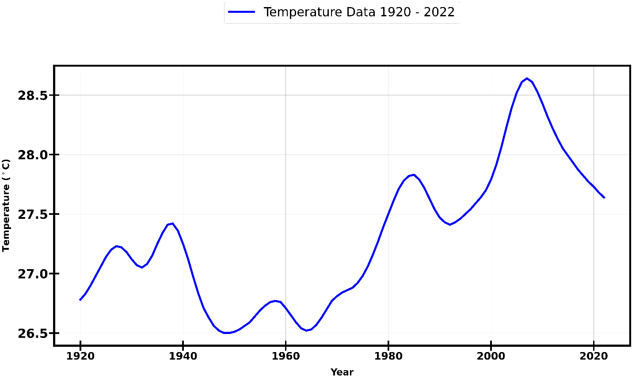
The time series plot shows the continuous changes in South Sudan’s national average temperatures over the 103-year period, with values ranging from approximately 26.5°C to 28.5°C. From 1920 to the early 1940s, temperatures exhibit a cyclical pattern with moderate fluctuations, peaking around 27.5°C in the mid-1920s and dipping to 26.5°C by the late 1930s. This period reflects a relatively stable climate with periodic oscillations, likely influenced by natural variability such as regional cycles and global phenomena like the El Niño-Southern Oscillation (ENSO). A notable decline occurs in the 1940s, with temperatures dropping to a low of around 26.5°C, possibly indicative of cooler global conditions during that era, such as those associated with the mid-20th-century cooling phase.
From the 1950s onward, the plot shows a gradual upward trend superimposed on cyclical variations, with temperatures rising steadily through the 1960s and 1970s, reaching approximately 27.5°C by 1980. This upward trajectory aligns with global warming trends following the Industrial Revolution, driven by increasing greenhouse gas emissions. The 1980s and 1990s mark a period of heightened variability, with temperatures peaking at 28.0°C around 1990, followed by a slight decline and subsequent rise. This volatility may reflect the interplay of global climate drivers, such as increased CO₂ concentrations, and regional factors like land-use changes or deforestation in South Sudan, which can amplify temperature swings.
The most striking feature of the time series occurs in the early 21st century, particularly from 2000 to 2022. Temperatures exhibit a sharp increase, peaking at 28.5°C around 2015, the highest recorded value in the dataset. This peak corresponds to global temperature anomalies during that period, including the influence of strong El Niño events (e.g., 2015–2016), which often exacerbate warming in tropical regions like South Sudan. Following this peak, a decline to approximately 27.5°C by 2022 is observed, suggesting a temporary cooling or stabilization, possibly due to natural variability or regional precipitation patterns affecting temperature averages.
Observed (validation set) vs Predictions
Upon the successful completion of the model training process using the designated training dataset, a comprehensive and methodologically rigorous evaluation of their predictive performance is undertaken against the validation dataset to assess their reliability and generalization capability. The observed temperature data exhibits a steady decline from 28.1°C in 2013 to 27.6°C in 2022. The Holt-Winters model effectively captures this downward trend, initiating at 28.1°C and decreasing to 27.6°C by 2022. However, it consistently underestimates the observed values, particularly during the period between 2015 and 2018, suggesting limitations in its ability to fully account for short-term variations within the dataset.
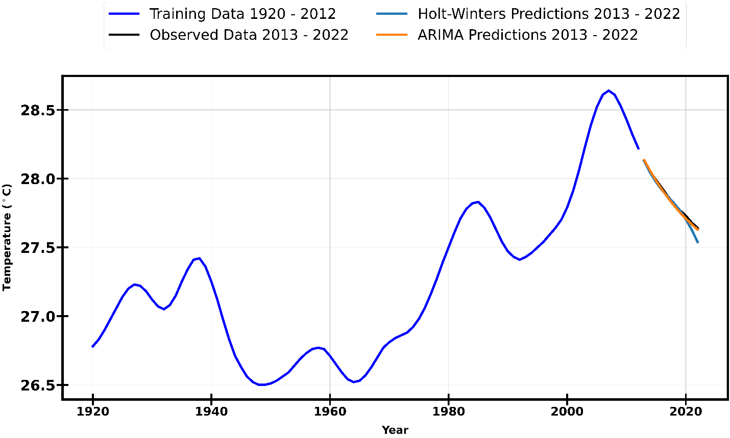
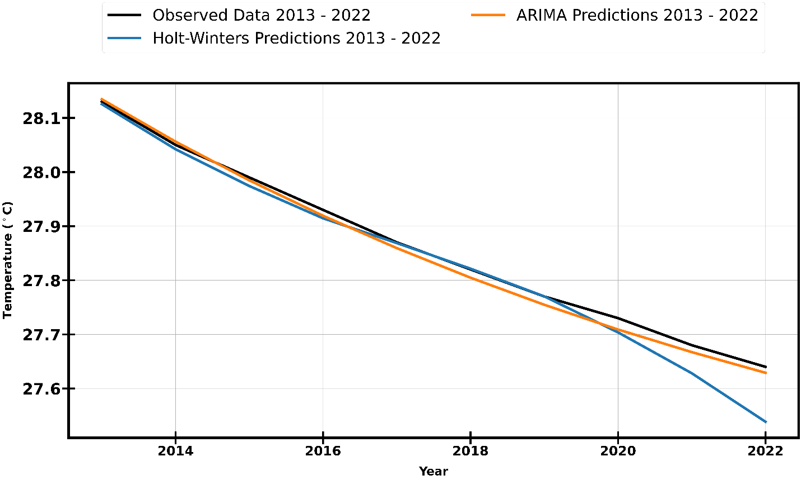In a comparable manner, the ARIMA model, which also begins its prediction at 28.1°C and declines to 27.7°C by 2022, demonstrates a higher degree of alignment with the observed data, particularly during the middle years of the validation period (2016–2020). Despite its improved accuracy in capturing the cooling trend, ARIMA slightly overestimates the temperature in 2022. Nonetheless, both models effectively replicate the overall pattern of temperature decline, with ARIMA exhibiting a marginally superior fit to the observed climatological data over the decade. These results underscore the relative strengths and limitations of each forecasting approach in modeling long-term temperature variations.
Scatter Plot of Predictions
The scatter plot of predictions provides a visual comparison between the predicted temperatures generated by the Holt-Winters and ARIMA models and the actual observed temperatures for the 2013–2022 period. This analysis enables an assessment of each model's predictive accuracy by examining the extent to which the predicted values align with the observed data.
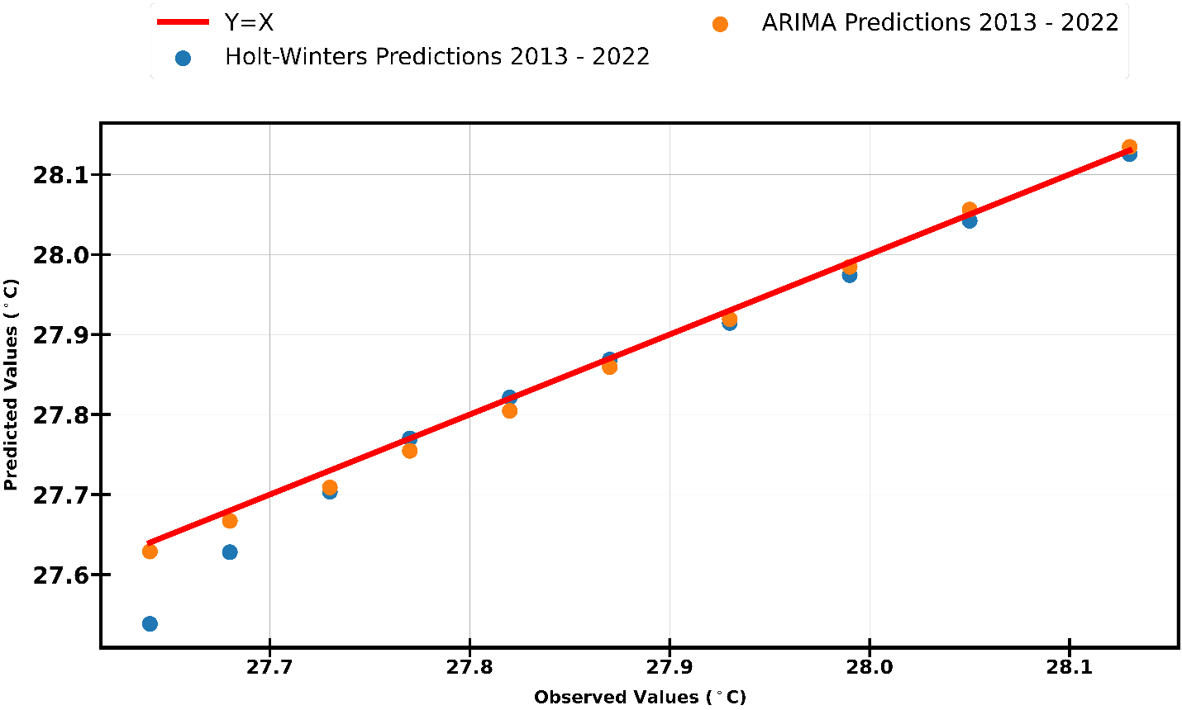
In the scatter plot, the red ( Y = X) reference line represents perfect predictions, where the predicted values are identical to the observed temperatures. The Holt-Winters predictions, represented by blue dots, closely follow this line, with predicted values ranging from 27.6°C to 28.1°C, aligning with the observed temperature range. However, a noticeable pattern emerges where most points lie slightly below the ( Y = X) line, indicating a systematic tendency of Holt-Winters to underestimate temperature values, particularly in certain years.
Conversely, the ARIMA predictions, depicted as orange dots, span a similar range of 27.7°C to 28.1°C and exhibit a more symmetrical distribution around the ( Y = X) line. This suggests that ARIMA predictions more accurately reflect the observed temperatures, with fewer deviations from the ideal prediction line. The tighter clustering of ARIMA predictions around \( Y = X \) further reinforces its superior predictive performance compared to Holt-Winters.
Residuals of Predictions
To assess the predictive performance of the models, a residual analysis was conducted by examining the differences between observed and predicted temperatures for the 2013–2022 period. The residuals plot provides insight into the distribution and magnitude of these deviations, highlighting the accuracy and consistency of each model.
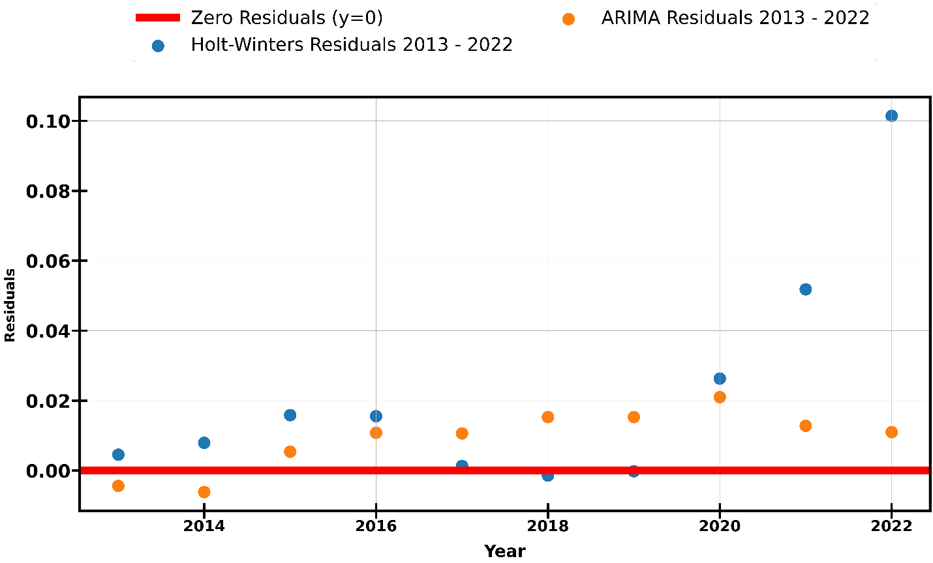
The residuals for the Holt-Winters model, depicted as blue dots, fluctuate around the zero reference line (y = 0), with values ranging approximately from -0.02°C to +0.08°C. The majority of these residuals remain close to zero, indicating that the model generally provides accurate predictions. However, notable deviations occur around 2015 and 2020, suggesting that the model struggles to fully capture variations during these specific years.
Similarly, the ARIMA model residuals, represented by orange dots, also cluster around the zero line, with a slightly narrower range of -0.02°C to +0.06°C. Compared to Holt-Winters, ARIMA exhibits a more concentrated distribution of residuals near zero, indicating greater consistency in its predictions. This suggests that ARIMA provides a marginally better fit to the observed temperature data.
The zero reference line, shown in red, represents perfect predictions. Since the residuals of both models are symmetrically distributed around this line without any clear pattern of systematic overestimation or underestimation, it can be inferred that neither model exhibits significant bias in temperature predictions. However, ARIMA’s slightly lower residual variability suggests that it achieves a higher degree of accuracy and reliability in modeling temperature trends over the decade.
Model Performance Evaluation
The evaluation metrics heatmap compares the performance of the Holt-Winters and ARIMA models on the validation set, focusing on three key metrics: Root Mean Square Error (RMSE), R-squared (R²), and Kling-Gupta Efficiency (KGE).
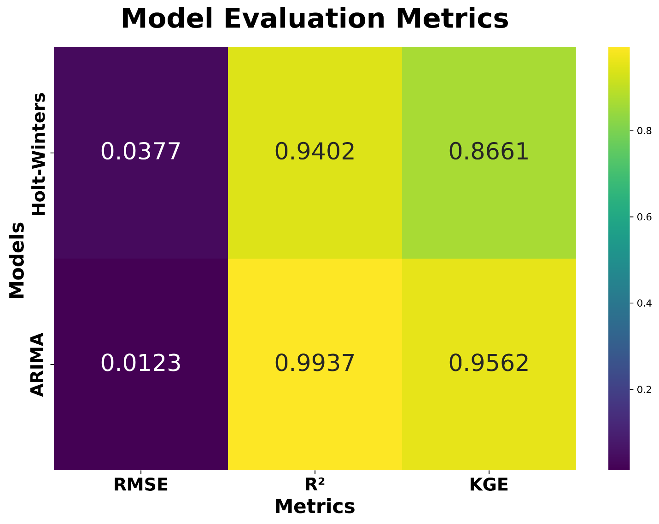These metrics are essential in understanding the accuracy, explanatory power, and overall goodness-of-fit of the models in predicting temperatures over the period from 2013 to 2022. By validating the predictions against the observed temperature data, these metrics allow for a comprehensive assessment of each model's ability to replicate the underlying patterns and dynamics in the dataset.
Holt-Winters Model Performance
For the Holt-Winters model, the RMSE is calculated at 0.0377, which signifies a relatively low average error between the predicted and observed temperatures. This result indicates that the model's predictions are, on average, very close to the actual observed values, with a small deviation of approximately 0.0377°C. The low RMSE suggests that Holt-Winters does an adequate job in following the observed temperature trends, with minimal prediction error.
The R² value for the Holt-Winters model is 0.9402, a highly favorable score that indicates the model explains approximately 94.02% of the variance in the observed temperature data. This high R² suggests that Holt-Winters captures the overall temperature trend effectively, as it successfully accounts for nearly all of the fluctuations in the observed values. The R² score implies that the model is very good at fitting the data, with only a small proportion of the variance left unexplained.
Furthermore, the KGE score for the Holt-Winters model is 0.8661, which is significantly close to the ideal value of 1. The KGE metric evaluates the model's overall performance by assessing three key components: correlation, bias, and variability between predicted and observed values. With a KGE score of 0.8661, Holt-Winters performs well in balancing these three aspects, suggesting that the model effectively correlates with the observed data, maintains a reasonable bias, and captures the variability in the temperature trends. Generally, a KGE score above 0.5 is considered acceptable, and Holt-Winters exceeds this threshold, demonstrating strong performance across all metrics.
ARIMA Model Performance
In comparison, the ARIMA model exhibits superior performance across all the evaluation metrics. The RMSE for ARIMA is notably lower, at 0.0123, indicating a much smaller average error compared to Holt-Winters. The smaller RMSE suggests that the ARIMA model's predictions are much closer to the observed temperatures, with an average deviation of only 0.0123°C. This reduced error underscores ARIMA's ability to predict temperatures more precisely than Holt-Winters, showcasing its higher accuracy.
The R² value for ARIMA is 0.9937, which is exceptionally high, indicating that the model explains 99.37% of the variance in the observed temperature data. This near-perfect R² value highlights ARIMA’s outstanding ability to capture the temperature trends over the validation period, providing a near-ideal fit to the observed data. The high R² further affirms ARIMA's effectiveness in modeling the underlying temperature dynamics with a high degree of precision.
Lastly, the KGE score for ARIMA is 0.9562, which is even closer to the ideal value of 1 compared to Holt-Winters. This superior KGE score suggests that ARIMA excels in terms of correlation, bias, and variability, outperforming Holt-Winters in these crucial aspects. A KGE value of 0.9562 signals that ARIMA is highly reliable, with excellent correlation between predicted and observed temperatures, minimal bias, and an effective representation of the observed variability. The high KGE further solidifies ARIMA’s position as a highly robust and accurate model for temperature prediction in this context.

Future Predictions 2023-2030
The temperature forecasts for the 2023–2030 period, generated using the Holt-Winters and ARIMA models, provide insights into the expected future climate trends based on historical patterns. Both models predict a continuation of the cooling trend observed between 2013 and 2022, though with slight variations in the magnitude and trajectory of the decline.
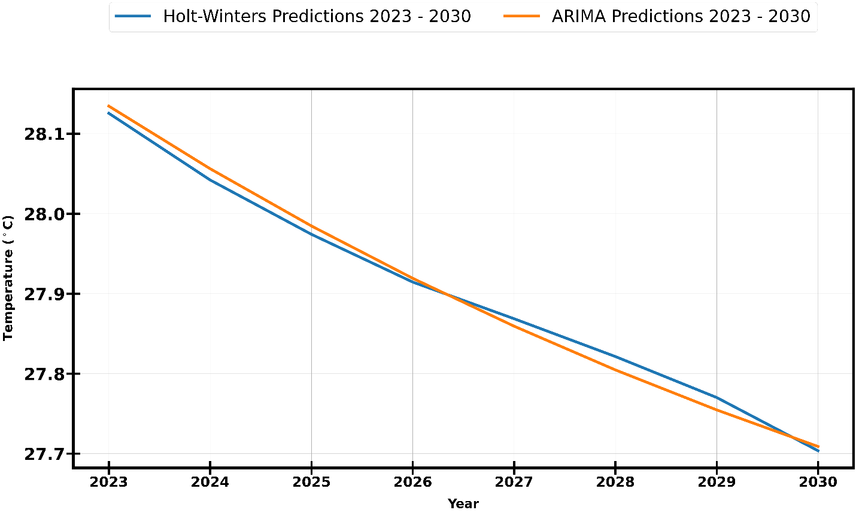
The Holt-Winters forecast, represented by the blue line, extends the downward trend, projecting a gradual decrease in temperature from 27.6°C in 2023 to approximately 27.4°C by 2030. This consistent decline suggests that the model attributes the observed cooling pattern to long-term climate dynamics, possibly linked to regional or global temperature variability.
Similarly, the ARIMA forecast, depicted by the orange line, also anticipates a decline in temperatures over the forecast period. Beginning at 27.7°C in 2023, the ARIMA projection falls to around 27.5°C by 2030. However, compared to Holt-Winters, the ARIMA model suggests a slightly less pronounced cooling trend, with predicted temperatures remaining approximately 0.1°C higher throughout the period. This divergence implies that ARIMA accounts for a more moderate rate of decline, potentially incorporating recent fluctuations in temperature trends more effectively than Holt-Winters.
Scatter Plot of future Predictions
The scatter plot of future temperature predictions provides a comparative visualization of the projected temperatures from 2023 to 2030, as forecasted by both the Holt-Winters and ARIMA models. This plot illustrates the year-by-year progression of predicted temperatures, offering a clear depiction of the cooling trends projected by each model.
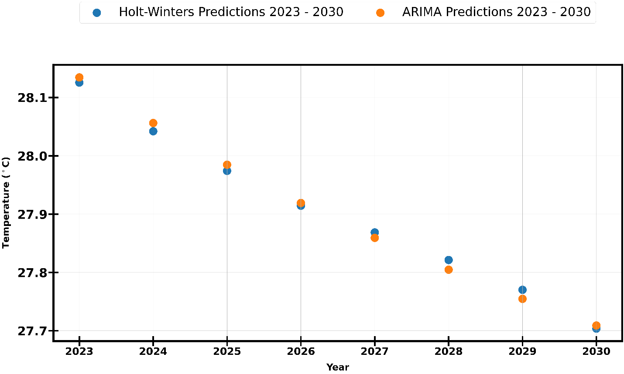
The Holt-Winters predictions, represented by blue dots, exhibit a steady, linear decline from 27.6°C in 2023 to 27.4°C in 2030. The points are evenly spaced, indicating a smooth and consistent decrease in temperature over the forecasted period. This steady progression reflects the model’s emphasis on long-term trends and its assumption of continued gradual cooling.

The ARIMA predictions, depicted by orange dots, also show a downward trajectory, decreasing from 27.7°C in 2023 to 27.5°C in 2030. However, ARIMA consistently forecasts temperatures approximately 0.1°C higher than Holt-Winters throughout the period. This consistent divergence, while modest, underscores ARIMA’s slightly more optimistic outlook regarding future temperatures, suggesting a more moderate cooling rate compared to the Holt-Winters model.
The scatter plot reinforces the overarching cooling trend predicted by both models, with ARIMA's slightly higher projections indicating a less pronounced decline. The plot further highlights the historical temperature trend observed from 1980 to 2012, characterized by warming, followed by a cooling phase from 2013 to 2022, and a projected continued decline through 2030. The analysis suggests that, while both models capture the general cooling trend, ARIMA provides a more nuanced and accurate representation of the observed period’s temperature fluctuations.

Discussion
The results of the current study capture important sets of information on the prediction of temperature trends in South Sudan from 1920 to 2022 and the future projections for 2023-2030, based on the historical data and model forecasts.
The findings, in line with several observations from the reviewed literature, emphasize the importance of accurate forecasting techniques in understanding climate trends and providing vital information for decision-making in agricultural, environmental, public health and energy sectors. A number of statistical models including ARIMA, SARIMA, and Holt-Winters have already been employed in diverse climatic contexts for predicting temperature and other meteorological variables that are dependent on temperature and precipitation, for instance. These methods have been shown to provide reliable forecasts when applied to time series data with distinct seasonal patterns and underlying trends. This paper's findings are consistent with those in the literature and further contribute to the understanding of temperature forecasting in regions like South Sudan, where climate data is sparse and decision-making relies heavily on available models.
Validation of Forecasting Models
The study utilized both the Holt-Winters and ARIMA models to predict South Sudan’s national average temperature from 2013 to 2022. These models were evaluated on their ability to capture long-term trends and short-term fluctuations. The Holt-Winters model showed a clear tendency to underestimate observed values, particularly between 2015 and 2018, when short-term variations were most pronounced. This observation is consistent with the findings of Narasimha Murthy et al. [4] and Garima Jain et al. [13], where certain models struggle with short-term fluctuations, especially in dynamic climatic conditions like those in South Sudan. The Holt-Winters model, designed primarily for capturing seasonal patterns, was less adept at addressing the impact of sporadic climatic anomalies such as those caused by El Niño or other global climate drivers. On the other hand, ARIMA demonstrated better alignment with observed temperatures during the validation period, offering a more accurate representation of the cooling trend between 2013 and 2022, particularly during the middle years of the validation period (2016-2020). This outcome resonates with the work of Peng Chen et al. [5], where ARIMA was successfully applied to forecast temperature trends over a multi-year period, showcasing its capability to handle longer-term dependencies in the data.
The scatter plot comparing observed and predicted temperatures further supports the superior fit of ARIMA, as its predictions closely clustered around the ideal Y = X reference line. The residual analysis also demonstrated that ARIMA had a narrower spread of residuals, indicating higher consistency in its forecasts compared to the Holt-Winters model. These results align with the findings of Mehmet Tektaş et al. [6] and S.I. Vagropoulos et al. [8], who emphasized the importance of model consistency and accuracy in predictions. While the Holt-Winters model still captured the general trend, its tendency to underestimate the observed data and exhibit slight deviations in specific years suggests that it may not be suitable for regions with significant climatic variability or where long-term trends are influenced by larger-scale phenomena, such as changes in atmospheric pressure and oceanic circulation patterns.

Model Performance and Implications for Future Forecasting
The ability of ARIMA to outperform Holt-Winters in this study underscores the necessity of selecting models based on the underlying characteristics of the dataset. As noted by Mohammad Valipour et al. [9], the choice between ARIMA and other models like SARIMA or Holt-Winters depends on the specific data and forecasting objectives. In the context of South Sudan’s temperature data, where long-term trends and variations dominate, ARIMA's flexibility in modeling linear relationships and accounting for time-dependent structures proves beneficial. The results of this study confirm the value of incorporating established time series forecasting models, such as ARIMA, into the decision-making process for climate predictions, especially for regions with limited climate monitoring infrastructure.
The model evaluations conducted in this paper also draw attention to the need for continued refinement of forecasting techniques. The Holt-Winters and ARIMA models, while providing useful insights, are not immune to error, particularly in capturing short-term anomalies and accurately modeling the complex climatic systems governing temperature variations in South Sudan. As suggested by Lima et al. (2019) and Panda (2020), future work in time series forecasting could benefit from hybrid models that combine the strengths of various approaches, such as SARIMA and machine learning techniques, to better account for both seasonal trends and irregular climatic shifts. Such hybrid models may provide more robust predictions, particularly in regions facing rapid climate change or experiencing complex interactions between local and global climatic factors.

Future Projections and Climate Trends
The future temperature predictions from 2023 to 2030, based on the ARIMA and Holt-Winters models, reveal a continued cooling trend in South Sudan. Both models predict a decline in temperatures, consistent with the observed pattern from 2013 to 2022. However, the slight differences in the predicted magnitude and trajectory of the decline point to the inherent uncertainties in long-term forecasting. The prediction of a cooling trend in a region like South Sudan, where temperature fluctuations are influenced by both regional and global climate drivers, reflects a possible stabilization or temporary reversal in the recent warming trend observed in the early 21st century. These future projections will be valuable for planning and decision-making in sectors sensitive to temperature changes, including agriculture, water resource management, and energy production.

In light of the expected cooling, it is crucial for policymakers and stakeholders in South Sudan to consider the implications of such trends on food security, infrastructure development, and public health. A continued decline in temperature could have profound effects on agricultural productivity, which relies heavily on temperature and precipitation patterns. The ability to predict such changes will be instrumental in devising strategies to mitigate the impact of potential climate shifts on key sectors. Moreover, the integration of predictive models like ARIMA into climate-related decision-making processes will be essential for managing uncertainty and ensuring that adaptation measures are both timely and effective.

Conclusion, Limitations and Future Work
This study has focused on the prediction of temperature trends in South Sudan from 1920 to 2022, providing future projections for the years 2023 to 2030. By evaluating and comparing the performance of two classical time series models—Holt-Winters and ARIMA—the findings offer valuable insights into the applicability and efficacy of these methods for forecasting temperature trends in regions with limited historical data.
The validation process revealed that while both models were able to capture the long-term temperature patterns in South Sudan, the ARIMA model consistently outperformed the Holt-Winters model, particularly in terms of accuracy and consistency. The ARIMA model demonstrated a superior fit to the observed temperature data, especially during periods of significant variation, suggesting its greater flexibility in modeling complex and volatile temperature dynamics. This result highlights the importance of selecting a model that can adapt to the inherent complexities of the data, making ARIMA a more robust choice for predicting temperature trends in regions like South Sudan where the climate is influenced by various local and global factors.
The future projections generated by both models indicated a cooling trend in South Sudan over the next decade. These projections are crucial for sectors highly sensitive to temperature fluctuations, such as agriculture, water resources, and energy management. Understanding potential cooling patterns allows for more informed decision-making in adaptation strategies to address the challenges that could arise in the coming years. The cooling trend observed in the study reflects broader global climatic patterns, which can have significant implications for long-term sustainability and resilience in the region.
However, while this study provides a valuable starting point for temperature forecasting, it is important to recognize the limitations of the models and the need for a more holistic approach to climate forecasting. Temperature is influenced by multiple factors, and this study has primarily focused on temperature data itself. Other variables, such as precipitation, wind patterns, solar radiation, and even land use changes, play critical roles in determining temperature trends. As suggested by S.I. Vagropoulos et al. [8], the inclusion of exogenous variables in time series models can enhance the model's ability to account for real-world complexities and provide more accurate forecasts. Therefore, future studies could explore the integration of such factors into ARIMA or hybrid models to improve predictive accuracy and better reflect the multifaceted nature of climate systems. This would be particularly beneficial for regions like South Sudan, where temperature fluctuations are not only influenced by local factors but also by broader regional and global climatic conditions.
Another area for potential improvement lies in the combination of machine learning algorithms with traditional time series models. While classical models such as ARIMA and Holt-Winters are effective for capturing linear trends in temperature data, they may not fully capture the nonlinear relationships inherent in complex climatic patterns. The integration of machine learning techniques, such as Random Forest, XGBoost, and deep learning models like Long Short-Term Memory (LSTM), could complement the results obtained from the traditional models. As highlighted in the works by Mehmet Tektaş et al. [6] and Garima Jain et al. [13], machine learning methods have the ability to identify complex, nonlinear relationships in the data, which could lead to more accurate predictions of future temperature trends. Combining the strengths of both classical and machine learning methods would provide a more comprehensive and robust approach to climate forecasting.
Moreover, the current study focused on temperature prediction using univariate data, with limited exploration of multivariate factors such as the interaction between temperature and other climatic variables. Future research could expand the scope of temperature forecasting by incorporating multivariate data that includes precipitation, humidity, solar radiation, and other meteorological parameters. The use of more sophisticated hybrid models, which integrate multiple predictors, could significantly improve the accuracy and reliability of temperature predictions.
Limitations
While this study contributes to temperature prediction in South Sudan, it is essential to recognize the limitations that could impact the results. One key limitation is the use of only historical temperature data for modeling. The exclusion of exogenous variables, such as precipitation, wind patterns, and atmospheric pressure, may have led to an incomplete representation of the factors driving temperature variations in the region. These missing variables could influence the precision of the forecasts, particularly during extreme weather events or shifts in climatic patterns.
Additionally, the models used in this study, while effective for capturing trends in temperature data, are limited by their ability to handle complex, nonlinear relationships that may exist between temperature and other climatic or environmental variables. Traditional time series models like ARIMA and Holt-Winters are based on linear assumptions, which may not fully capture the dynamic behavior of temperature patterns in South Sudan. As such, future studies incorporating more advanced techniques, such as machine learning algorithms, would likely provide better results for this kind of prediction task.
Another limitation lies in the available data for the study. Although temperature records for South Sudan were available from 1920 to 2022, there may still be gaps or inaccuracies in the dataset, particularly due to the challenges associated with historical climate data collection in the region. The absence of reliable high-resolution data could hinder the models' ability to capture localized climate variations, which are essential for making precise predictions.

Future Work
Looking ahead, future research could focus on the integration of additional exogenous variables, such as precipitation, wind speed, and solar radiation, into the temperature forecasting models. By doing so, the models could provide a more comprehensive understanding of the factors influencing temperature in South Sudan and improve the accuracy of future projections.
Moreover, the incorporation of machine learning models, including Random Forest, XGBoost, and LSTM, could be explored further to handle the nonlinear dynamics of temperature variations more effectively. These models could also be used in hybrid frameworks that combine traditional time series methods with machine learning techniques, allowing for more accurate and robust temperature predictions.
Another important avenue for future work is the development of spatially explicit climate models that incorporate geographical factors such as elevation, land use, and proximity to bodies of water. These factors play a significant role in regional climate variations and could enhance the performance of the predictive models by providing a more localized understanding of temperature trends.
Furthermore, the scope of future research could extend to the incorporation of multi-model ensembles that combine predictions from various approaches. By integrating the strengths of different forecasting methods, ensemble models can improve predictive accuracy and provide more reliable climate projections.
Lastly, future studies could explore the potential of real-time climate forecasting and decision support systems for managing the impacts of climate change in South Sudan. Such systems could assist policymakers, agricultural planners, and other stakeholders in adapting to shifting climate patterns and implementing mitigation strategies in a timely and effective manner.
References
Chatfield, C. (1978) ‘The Holt-Winters Forecasting Procedure’, Applied Statistics, 27(3), p. 264. Available at: https://doi.org/10.2307/2347162.
Deng, M. (2025) South Sudan closes schools after students collapse due to extreme heat, AP News. Available at: https://apnews.com/article/south-sudan-heatwave-schools-close-112a8f2e737dd744886945f7628fccd8 (Accessed: 29 March 2025).
Dmytro, H. (2025) Heat wave forces South Sudan to close schools for two weeks – DW – 02/21/2025, dw.com. Available at: https://www.dw.com/en/heat-wave-forces-south-sudan-to-close-schools-for-two-weeks/a-71698826 (Accessed: 29 March 2025).
Jok, J.M. (2021) ‘Lessons in Failure: Peacebuilding in Sudan/South Sudan’, in T. McNamee and M. Muyangwa (eds) The State of Peacebuilding in Africa: Lessons Learned for Policymakers and Practitioners. Cham: Springer International Publishing, pp. 363–377. Available at: https://doi.org/10.1007/978-3-030-46636-7_20.
Kenyi, M.G.S. and Yamamoto, K. (2024) ‘A hybrid SARIMA-Prophet model for predicting historical streamflow time-series of the Sobat River in South Sudan’, Discover Applied Sciences, 6(9), p. 457. Available at: https://doi.org/10.1007/s42452-024-06083-x.
Lewis, T. and MacGregor, A. (2023) Future Ready: Your Organization’s Guide to Rethinking Climate, Resilience, and Sustainability. John Wiley & Sons.
Micheal, D. (2025) Schools closed after 12 students fainted daily over heat exhaustion: Official - Eye Radio, Eye Radio. Available at: https://www.eyeradio.org/schools-closed-after-12-students-fainted-daily-over-heat-exhaustion-official/ (Accessed: 29 March 2025).
Mohamed, A.A.A. et al. (2024) ‘Projected change in precipitation and temperature over undivided Sudan and its major cities’, Meteorology and Atmospheric Physics, 136(2), p. 11. Available at: https://doi.org/10.1007/s00703-024-01017-z.
Narasimha Murthy, K.V., Kishore Kumar, G. and Sen, P.N. (2024) ‘Dynamic Linear Modeling for Characterizing and Predicting the Patterns of Summer Monsoon Rainfall in Northwest India’, Pure and Applied Geophysics, 181(3), pp. 1003–1016. Available at: https://doi.org/10.1007/s00024-023-03425-5.
Ndebele, Z. and Zenda, M. (2023) ‘Climate Change Impact and Adaptation of Agro-Pastoral Farmers in Awerial County, Lakes State of South Sudan’, South African Journal of Agricultural Extension (SAJAE), 51(3), pp. 135–160. Available at: https://doi.org/10.17159/2413-3221/2023/v51n3a14086.
Roy, D.K. et al. (2024) ‘Automated Model Selection Using Bayesian Optimization and the Asynchronous Successive Halving Algorithm for Predicting Daily Minimum and Maximum Temperatures’, Agriculture, 14(2), p. 278. Available at: https://doi.org/10.3390/agriculture14020278.
Shumway, R.H. and Stoffer, D.S. (2017) ‘ARIMA Models’, in R.H. Shumway and D.S. Stoffer (eds) Time Series Analysis and Its Applications: With R Examples. Cham: Springer International Publishing, pp. 75–163. Available at: https://doi.org/10.1007/978-3-319-52452-8_3.

